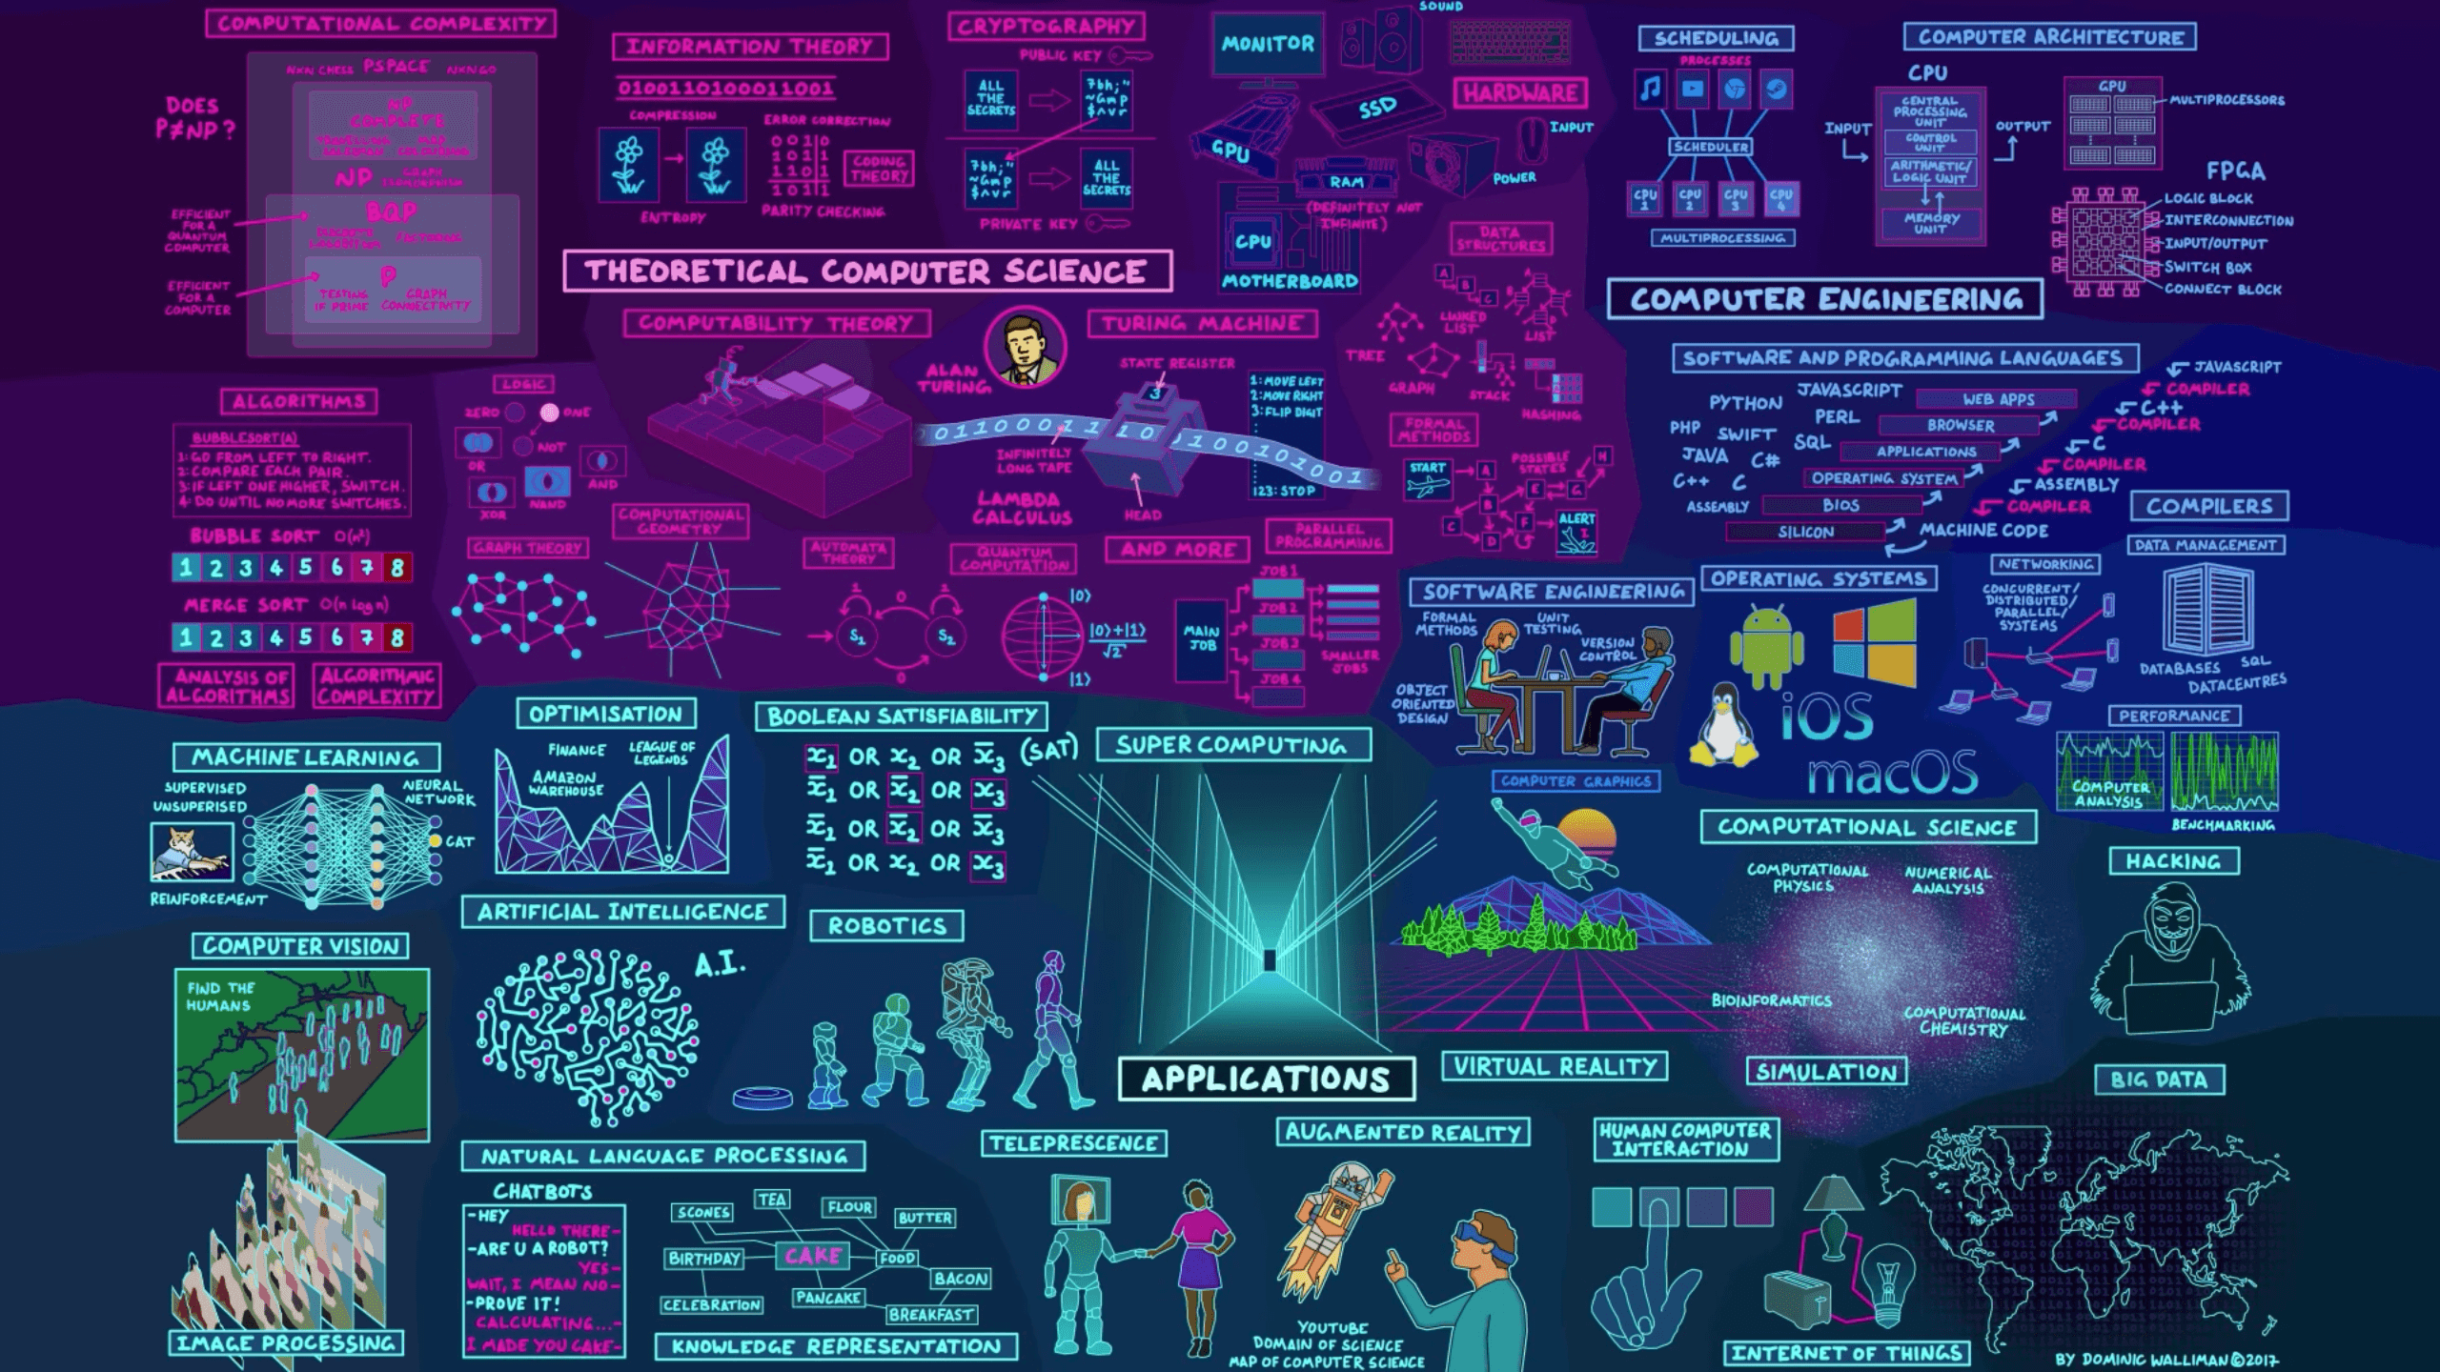
Name: | Waleed Afzal
Course: | Software Engineering
Roll Number: | 23P-0566
Section: | 5C
Assignment No: | #01
Date: | 6/9/25

Table of Contents
Eventoria – Venue Booking Platform 3
1. Introduction 3
1.1 Purpose 3
1.2 Scope 3
1.3 Definitions, Acronyms, Abbreviations 3
1.4 References 4
1.5 Overview 4
2. General Description 4
2.1 Product Perspective 4
2.2 Product Functions 4
2.3 Users Characteristics 5
2.4 General Constraints 5
2.5 Assumptions & Dependencies 5
3. Specific Requirements 5
3.1 Functional Requirements 5
3.2 Design Constraints: 7
3.3 Non-Functional Requirements: 7
3.3.1 Security 7
3.3.2 Performance 7
3.3.3 Usability 7
3.3.4 Reliability 7
3.3.5 Availability 7
4. System Model Diagrams 7
4.1 Use Case Diagram 7
4.2 Activity Diagram 9
4.3 Sequence Diagram 9
4.4 System Sequence Diagram 10
4.5 Class Diagram 11
4.6 Domain Model Diagram 12
4.7 ER Diagram 12
4.8 Architecture Diagram 13
5. Other Requirements 13
5.1 SDLC Model Justification 13
5.2 Future Scope 13

Eventoria – Venue Booking Platform

Introduction

Purpose
This document describes the functional and non-functional requirements for the software application Eventoria, a comprehensive venue booking platform. The purpose of this SRS is to provide a detailed overview of the system's capabilities, user interactions, and constraints. This document is intended for the project stakeholders, including clients, developers, testers, and project managers, and will serve as the primary reference for the design, development, and validation phases of the project.

Scope
Eventoria is a web-based application that will serve as a centralized marketplace for event venues and services. The product aims to:
- Provide Users/Customers with a platform to discover, compare, and book venues for various events (e.g., weddings, conferences, parties).
- Provide Vendors with a tool to register, manage, and market their venues to a wider audience.
- Provide Service Providers (e.g., caterers, photographers) with a platform to list their services and be hired for events.
- Automate and streamline the booking, payment, and scheduling processes.
- Generate analytical reports for vendors and administrators on performance metrics.
The system will not handle the physical execution of events (e.g., setup, logistics on-site) or directly manage vendor staff.

Definitions, Acronyms, Abbreviations
- SRS: Software Requirements Specification
- User/Customer: An individual or organization looking to book a venue or service for an event.
- Vendor: A business entity that owns and lists venues on the platform (e.g., restaurant owner, hall manager).
- Service Provider: A business or individual offering ancillary event services (e.g., catering, decoration, photography).
- Admin/Administrator: A system user responsible for managing the platform, users, and content.
- UI: User Interface
- API: Application Programming Interface

References
- IEEE Std 830-1998, IEEE Recommended Practice for Software Requirements Specifications.
- Academia.edu (Software Requirements Specification BOOKING SYSTEM)
- Scribd.com (SRS Event Management System)

Overview
The remainder of this SRS is organized as follows: Section 2 provides a general description of the product. Section 3 details the specific functional and non-functional requirements. Section 4 contains system models and artifacts (diagrams). Section 5 covers other requirements including SDLC justification and future scope.

General Description

Product Perspective
Eventoria is a self-contained, web-based application. It will interact with several external systems:
- Payment Gateway: A third-party system (e.g., Stripe, PayPal) to securely process financial transactions.
- Email Service: A third-party service (e.g., SendGrid, Mailchimp) to send booking confirmations, notifications, and promotional emails.
- Maps API: A service (e.g., Google Maps API) to display venue locations and provide directions to users.

Product Functions
The major functions of Eventoria include:
- User Management: Registration, login, and profile management for all user types.
- Venue & Service Catalog: Browsing, searching, and filtering of venues and services.
- Listing Management: Vendors and Service Providers can create, read, update, and delete (CRUD) their listings.
- Booking System: A calendar-based system for checking availability, making reservations, and sending requests.
- Payment Processing: Integration with a secure payment gateway for handling deposits and payments.
- Review & Rating System: Users can leave reviews and ratings for venues and services they have booked.
- Reporting Dashboard: Vendors and Admins can view reports on bookings, revenue, and popularity.
- Administrative Panel: For managing users, resolving disputes, and overseeing platform health.

Users Characteristics
- Users/Customers: Technically literate but with varying levels of expertise. They require an intuitive, GUI-based interface. No specialized training is required.
- Vendors/Service Providers: Comfortable with web interfaces for business management. May require guidance on optimizing their listings.
- Administrator: Highly technically skilled. Understands database management and system administration. Requires a powerful and detailed admin interface.

General Constraints
- The system must be developed within a 6-month timeframe.
- The application must be a responsive web application compatible with modern browsers (Chrome, Firefox, Safari, Edge).
- The system must comply with data protection regulations.
- All financial transactions must be compliant via the third-party payment gateway.

Assumptions & Dependencies
- Assumptions: Users will have a reliable internet connection and a modern web browser. Vendors will provide accurate information for their listings.
- Dependencies: The project is dependent on the successful integration of third-party APIs (Payment Gateway, Email Service, Maps API). Any changes to these external APIs may impact the system's functionality.

Specific Requirements

Functional Requirements
- User Registration & Authentication
  - The system shall allow a user to register as a Customer, Vendor, or Service Provider.
  - The system shall allow a registered user to log in using their email and password.
  - The system shall allow a user to reset a forgotten password.

2 Venue & Service Management
2.1 A Vendor shall be able to create a new venue listing, providing details (name, description, address, capacity, pricing, photos).
2.2 A Vendor shall be able to update or delete their existing venue listings.
2.3 A Service Provider shall be able to create, update, and delete their service listings.

3: Search & Discovery
3.1: A Customer shall be able to search for venues by location, date, capacity, and event type.
3.2: The system shall display search results in a list and map view.
3.3: A Customer shall be able to view detailed information about a selected venue or service.

4: Booking & Payment
4.1: A Customer shall be able to check the availability of a venue for a specific date.
4.2: A Customer shall be able to submit a booking request.
4.3: The system shall process payments securely via the integrated Payment Gateway.
4.4: The system shall send an email confirmation upon successful booking and payment.

5: Review System
5.1: A Customer shall be able to submit a review and rating for a booked venue/service after the event date has passed.

6: Reporting
6.1: A Vendor shall be able to view a dashboard showing monthly bookings, revenue, and customer ratings.
6.2: An Administrator shall be able to generate system-wide reports on total transactions and user growth.

Design Constraints:
- The front-end shall be built using a modern JavaScript framework (React.js/Angular/Vue.js).
- The back end shall be built using a Node.js/Python (Django/Flask) framework.
- The data shall be stored in a relational SQL database (PostgreSQL/MySQL).
- The UI design shall follow Material Design principles.

Non-Functional Requirements:

Security
- All user passwords shall be hashed and salted (using bcrypt or equivalent).
- All data transmissions shall be encrypted using SSL/TLS.
- Users shall only be able to access and modify their own data (e.g., a Vendor cannot modify another Vendor's listing).

Performance
- The system shall load search results in under 2 seconds for 95% of queries under typical load (1000 concurrent users).
- The application server shall handle up to 1000 concurrent users.

Usability
- The user interface shall be intuitive enough for a new user to complete a booking within 5 minutes of first use.
- The system will achieve a System Usability Scale (SUS) score of 80 or above after beta testing.

Reliability
- The system shall have an uptime of 99.8%.
- The booking transaction process shall have a failure rate of less than 0.1%.

Availability
- The system shall be available 24/7, with scheduled maintenance windows communicated to users at least 24 hours in advance.

System Model Diagrams

Use Case Diagram

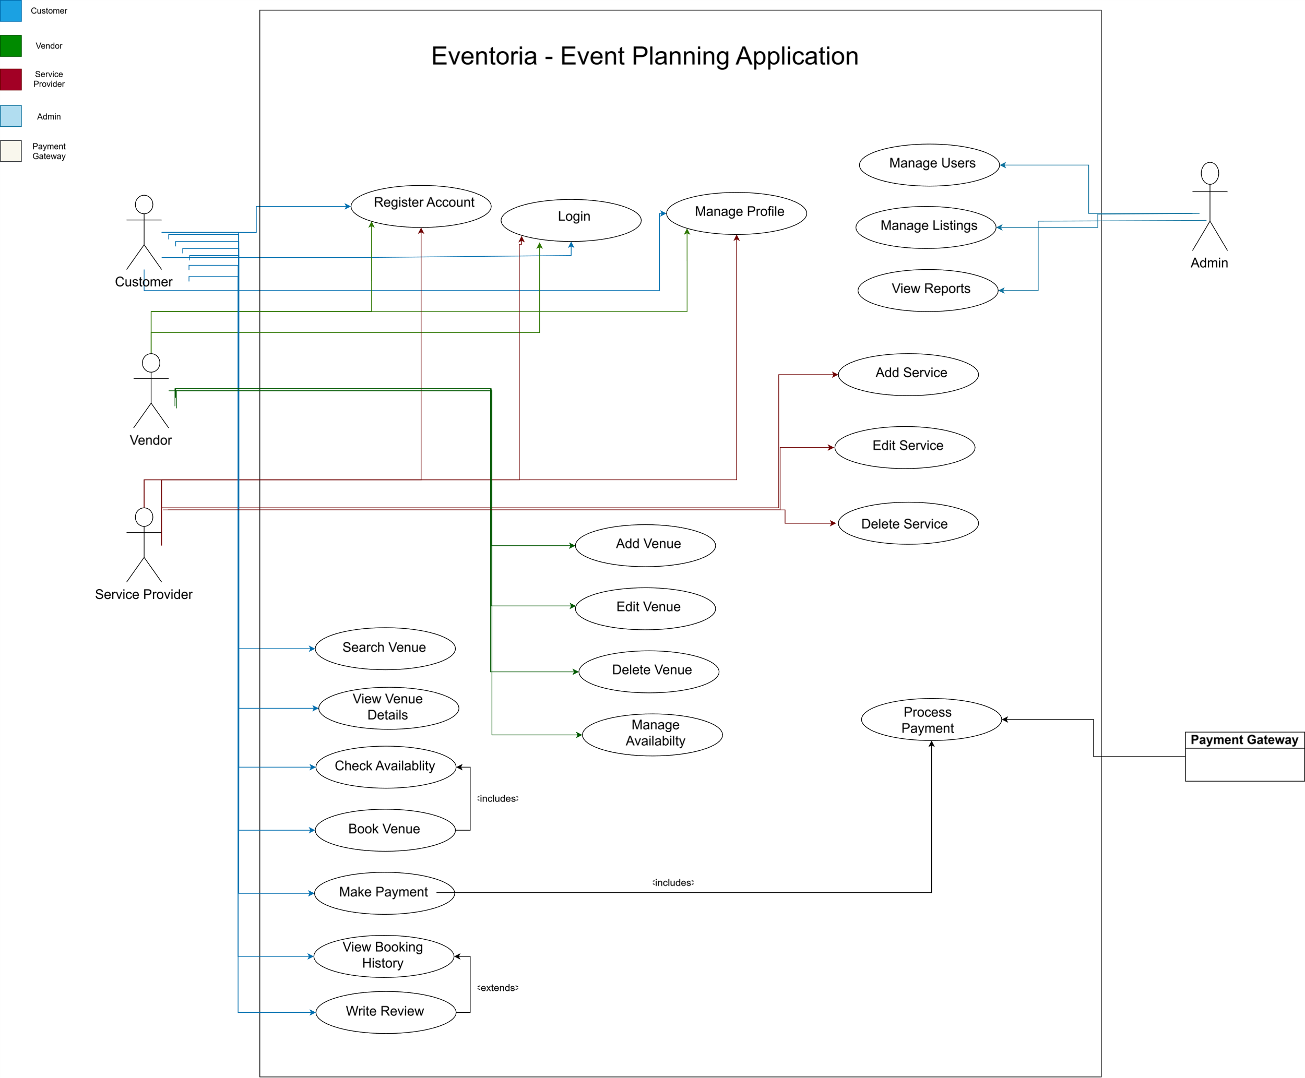

Activity Diagram
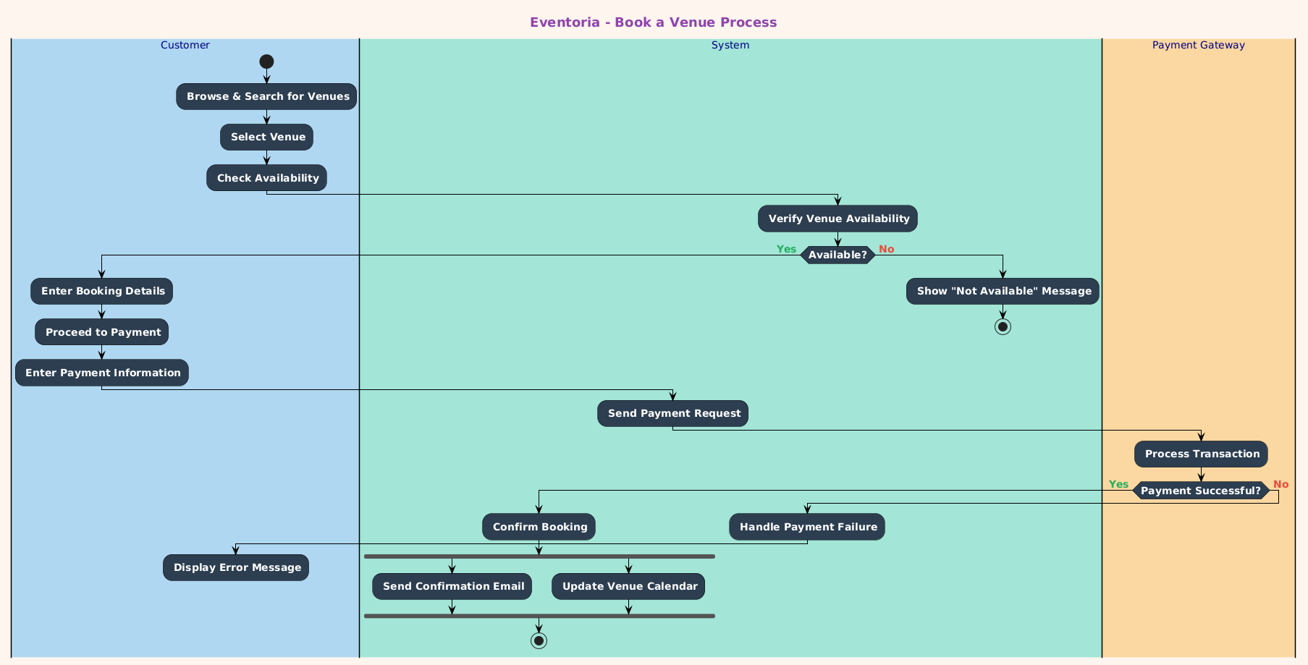

Sequence Diagram
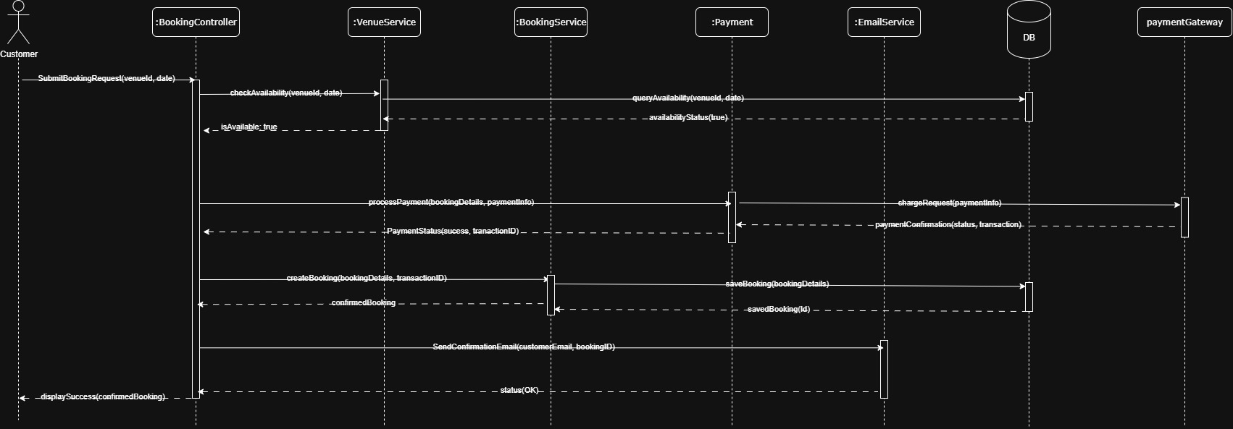

System Sequence Diagram
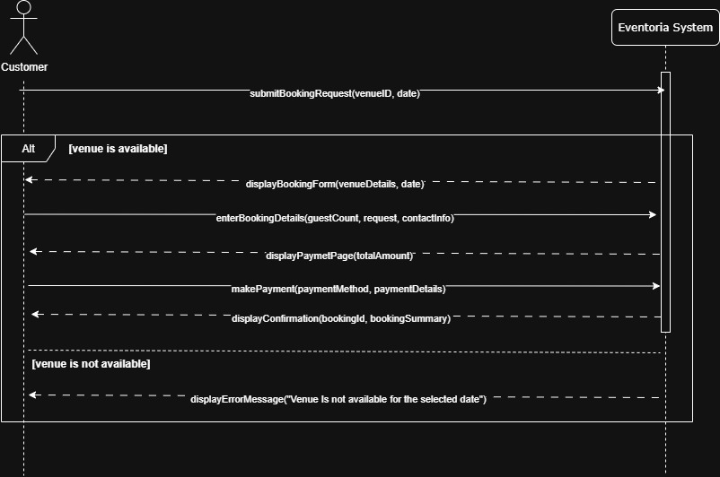

Class Diagram
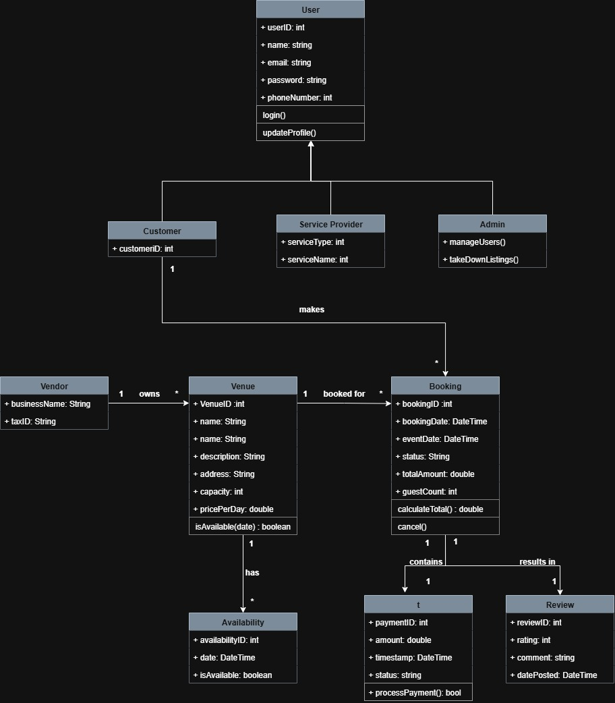

Domain Model Diagram
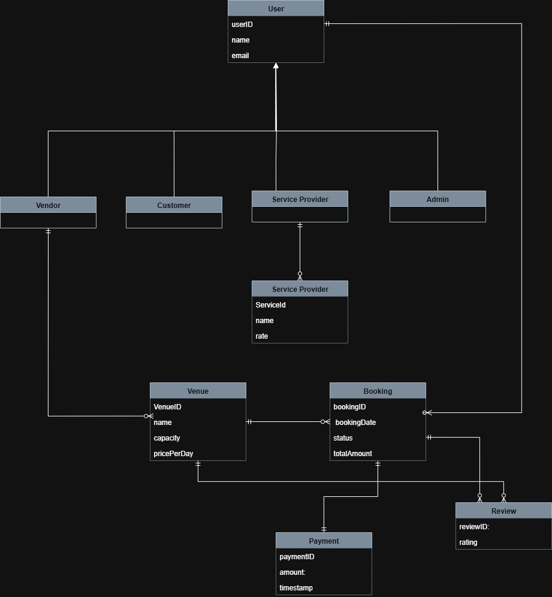

ER Diagram

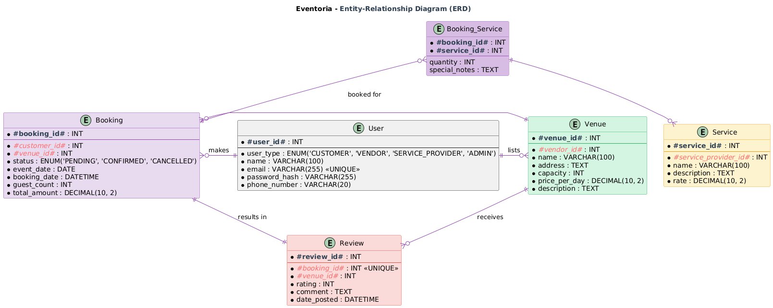

Architecture Diagram
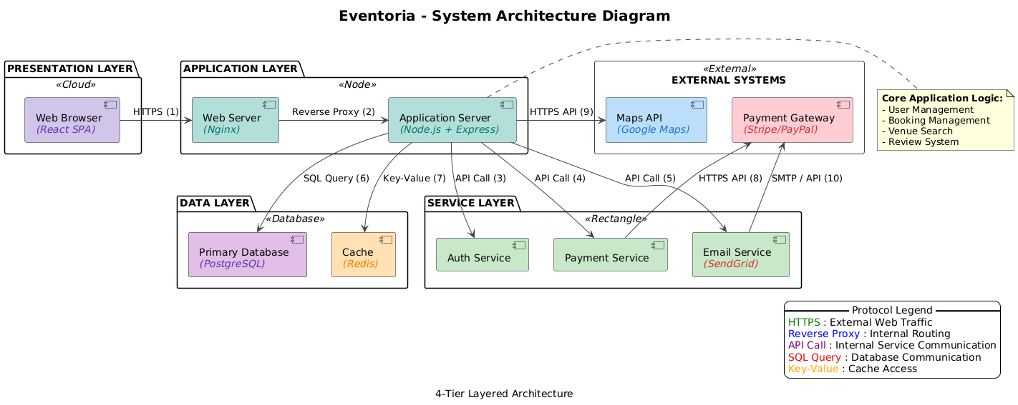

Other Requirements

SDLC Model Justification
- Adaptability to Change: Agile's iterative sprints allow for frequent feedback and requirement changes, which is crucial for a dynamic market like event booking.

- Risk Mitigation: Delivering a Minimum Viable Product (MVP) first allows for early testing and validation of core features like payments, reducing the risk of major failures.

- User-Centric Focus: Continuous collaboration with stakeholders ensures the developed features truly meet user needs and provide a superior experience for both customers and vendors.

Future Scope
- Mobile Applications: Native iOS and Android apps for a better mobile experience with push notifications for bookings and alerts.
- AI Recommendations: Machine Learning algorithms to provide personalized venue suggestions and predictive sales analytics for vendors.
- In-App Messaging: A real-time chat system for direct communication between customers and vendors to discuss event details.
- VR/AR Tours: Integration of 360-degree virtual tours for venues, allowing customers to explore spaces remotely.
- Global Expansion: Support for multiple languages, currencies, and regional payment methods to enter international markets.
- Loyalty Program: A rewards system where users earn points on bookings for discounts, encouraging customer retention.

----------------------------------------------------------- The End ----------------------------------------------------------

